
Data Structure and Algorithm
LAB MANUAL
Submitted to
Name | Dr. Rajkumar Batchu
Department | CSE
Designation | Assistant Professor
Submitted by
Name | M. Gokul krishna
Roll No | AV.SC.U4CSE25126
Year/Sem/Section | 2nd YEAR/SEM-3/CSE-B

S.no |  | programs | Pg.no |  |  | remark
1 |  | a) A rocket launch system displays a countdown before launch. Instead of using loop, implement the countdown from n to 1, followed by "Launch!".  b) Banks calculate the growth of an investment using compound interest. The formula requires calculating powers, which can be implemented recursively. Write a recursive program to calculate (power), where  P = principal growth factor,  n = number of years.  c) An HR department stores employee ID's in a list. Develop a recursive program to search for a given employee ID. Write a recursive function to search for an employee ID in a list.  d) In a logistics company, the number of possible ways to arrange n different packages is calculated using the factorial formula . Develop a recursive program to calculate the factorial of a given number.  e) Write a recursive Python program to print the first n terms of Fibonacci series. | 5-11
2 |  | a)write a python program to perform linear search on the given input  b)Write a python program to perform binary search on the given input. Verify by taking sorted array and unsorted array as a list. | 12-18
3 |  | A) write a python program to implement bubble sort, where the elements are taken from user.  B) write a python program to implement selection sort, where the elements are taken from user.  C) write a python program to implement insertion sort, where the elements are taken from user. | 19-24
4 |  | A) write a python program to implement Merge sort, where the elements are taken from user.  B) write a python program to implement Quick sort, where the elements are taken from user. | 25-29
5 | - Write a program to implement SLL with the below operations. Create linked list, Insert Beginning, Insert End, Insert at Index, delete by value, delete first node, delete last node, count number of nodes, display/transverse exit.  - Write a program to implement DLL with the below operations. Create linked list, Insert Beginning, Insert End, Insert at Index, delete by value, delete first node, delete last node, count number of nodes, display/transverse exit. |  |  | 30-36
6 | A)Write a python program to implement stack operations such as push, pop, peek, display using an array and a linked list. |  |  | 37-45

Week 1
- A rocket launch system displays a countdown before launch. Instead of using loop, implement the countdown from n to 1, followed by "Launch!".
Program:
def count(n):
if n == 0:
print("launch")
return
print(n)
count(n-1)
n= int(input("Enter countdown number: "))
count(n)
output:
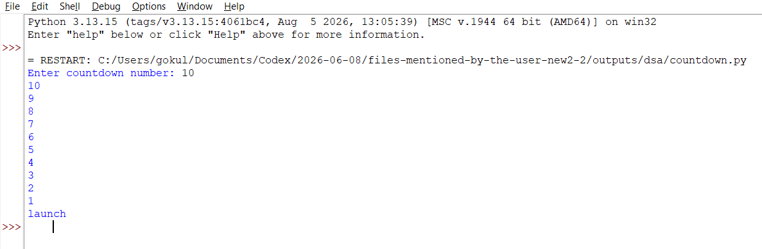
Explanation:
- Best Case: O(n)
- Worst Case: O(n)
- Time Complexity: O(n)
- Space Complexity: O(n)
- Reason: The function is called n times, so the time complexity is O(n). Since all recursive calls are stored in the call stack until the base case is reached, the space complexity is O(n).
Error Table:
s.no | Error obtained | Rectification
1. | Infinite loop | Iteration at correct place
2. | Calling function at wrong place | Placed with correct syntax

b) Banks calculate the growth of an investment using compound interest. The formula requires calculating powers, which can be implemented recursively. Write a recursive program to calculate (power), where
P = principal growth factor,
n = number of years.
Program:
def power(p,n):
if n == 0:
return 1
return p*power(p,n-1)
p = float(input("Enter the value of p: "))
n = int(input("Enter the value of n: "))
print("p^n = ",power(p,n))
Output:
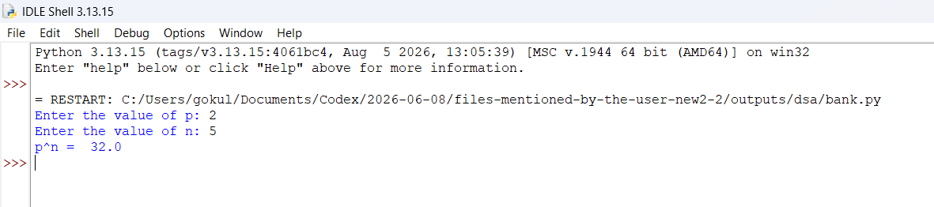
Explanation:
- Best Case: O(1)
- Worst Case: O(n)
- Time Complexity: O(n)
- Space Complexity: O(n)
Reason: The best case occurs when n = 0, because the function immediately returns 1, giving O(1) time and space. In the worst case, the function makes n recursive calls, resulting in O(n) time. The recursive calls are stored in the call stack, resulting in O(n) space.
Error Table:
s.no | Error obtained | Rectification
1. | Return 0 | Return 1
2. | Indentation error | Corrected using proper induntation

- An HR department stores employee ID's in a list. Develop a recursive program to search for a given employee ID. Write a recursive function to search for an employee ID in a list.

Program:
def search_employee(ids, target, index):
if index == len(ids):
return False

if ids[index] == target:
return True

return search_employee(ids, target, index + 1)

ids = [101, 102, 103, 104, 105]

target = int(input("Enter employee ID: "))

if search_employee(ids, target, 0):
print("Employee ID found")
else:
print("Employee ID not found")

output:
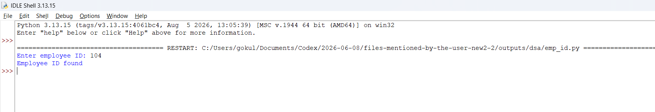

Explanation:
- Best Case: O(1)
- Worst Case: O(n)
- Time Complexity: O(n)
- Space Complexity: O(n)
Reason: The best case occurs when the required employee ID is the first element of the list, so only one comparison is needed, giving O(1) time and space. The worst case occurs when the employee ID is the last element or is not present in the list. In this case, all n elements are checked, resulting in O(n) time. Since recursive calls are stored in the call stack, the worst-case space complexity is O(n).
Error Table:
s.no | Error obtained | Rectification
1. | Forgot to declare n<=1 | rectified
2. | Formula mistake | rectified

- In a logistics company, the number of possible ways to arrange n different packages is calculated using the factorial formula . Develop a recursive program to calculate the factorial of a given number.

Program:
def factorial(n):
if n == 0 or n == 1:
return 1

return n * factorial(n - 1)

n = int(input("Enter n: "))
print("Factorial =", factorial(n))

output:

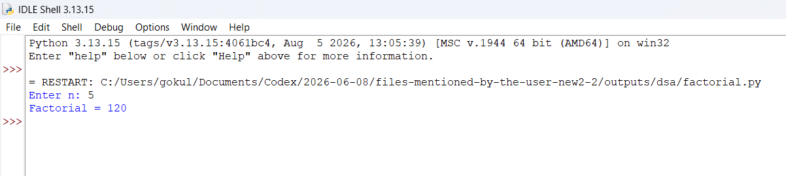
Explanation:
- Best Case: O(1)
- Worst Case: O(n)
- Time Complexity: O(n)
- Space Complexity: O(n)
Reason: The best case occurs when n is 0 or 1, because the function immediately returns 1, resulting in O(1) time and space. In the worst case, the function makes recursive calls from n down to 1, resulting in O(n) time. The recursive calls occupy the call stack, so the space complexity is O(n).
Error Table:
s.no | Error obtained | Rectification
1. | Emplist | Emp_list
2. | print | Return

- Write a recursive Python program to print the first n terms of Fibonacci series.

Program:
def fibonacci(n):
if n == 0:
return 0

if n == 1:
return 1

return fibonacci(n - 1) + fibonacci(n - 2)

n = int(input("Enter number of terms: "))

for i in range(n):
print(fibonacci(i), end=" ")

output:
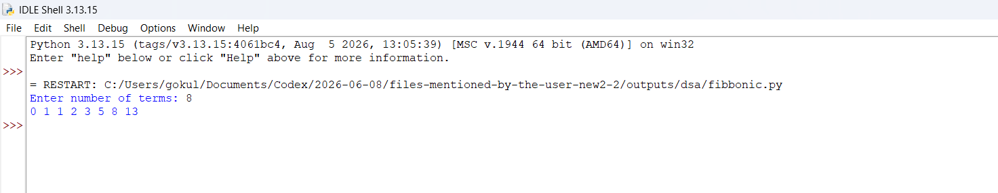

Explanation:
- Best Case: O(1)
- Worst Case: O(2ⁿ)
- Time Complexity: O(2ⁿ)
- Space Complexity: O(n)
Reason: The best case occurs when n is 0 or 1, because the function immediately returns the result, giving O(1) time and space. In the worst case, every recursive call creates two more recursive calls, causing the number of calls to grow exponentially. Therefore, the time complexity is O(2ⁿ). Although there are many recursive calls, the maximum depth of the call stack is n, so the space complexity is O(n).

s.no | Error obtained | Rectification
1. | n+1 | n-1
2. | Syntax error | Missed “(“ at the definig the function

Week-2:
a)Write a program to implement Linear Search.
Program:
# Taking the number of elements
n = int(input("Enter number of elements: "))

# Taking array elements from the user
arr = []

for i in range(n):
value = int(input("Enter element: "))
arr.append(value)

# Taking the element to search
target = int(input("Enter element to search: "))

# Linear search
found = False

for i in range(n):
if arr[i] == target:
print("Element found at position", i + 1)
found = True
break

if not found:
print("Element not found")

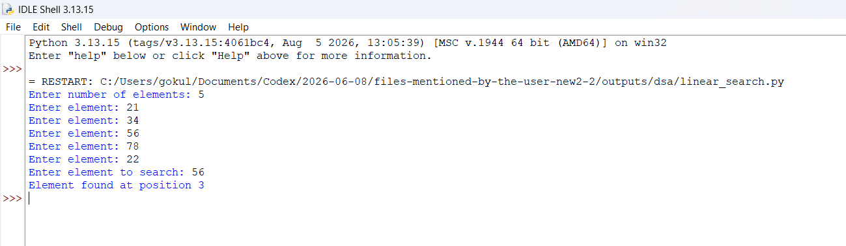
Output:

Explanation:
- Best Case: O(1)
- Worst Case: O(n)
- Time Complexity: O(n)
- Space Complexity: O(n) for storing the input array
Reason: In the best case, the required element is the first element, so only one comparison is required. In the worst case, the element is at the last position or is not present, so all n elements must be checked. Therefore, the worst-case time complexity is O(n).

Error Table:
s.no | Error obtained | Rectification
1. | Return placed in wrong place | Corrected later
2. | Calling the function | Rectified

- Write a program to implement Binary Search with sorted array as an input.
Program:
# Binary Search on a sorted array
# Taking the number of elements
n = int(input("Enter number of elements: "))

# Taking sorted array as input
arr = []

for i in range(n):
value = int(input("Enter element: "))
arr.append(value)

# Taking the element to search
target = int(input("Enter element to search: "))

# Binary search
low = 0
high = n - 1
found = False

while low <= high:
mid = (low + high) // 2

if arr[mid] == target:
print("Element found at position", mid + 1)
found = True
break

elif target < arr[mid]:
high = mid - 1

else:
low = mid + 1

if not found:
print("Element not found")

Output:
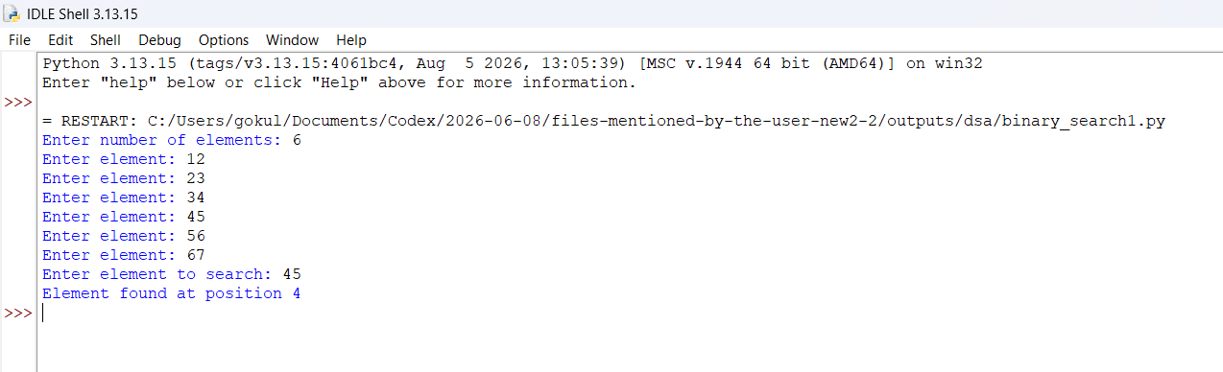

Explanation:
- Best Case: O(1)
- Worst Case: O(log n)
- Time Complexity: O(log n)
- Space Complexity: O(1)
Reason: In the best case, the target element is the middle element of the array, so it is found in the first comparison. In the worst case, the search range is repeatedly divided into half until the element is found or the range becomes empty. Therefore, the worst-case time complexity is O(log n). Since only a few variables such as low, high, and mid are used, the space complexity is O(1).

Error Table:
s.no | Error obtained | Rectification
1. | Mistakes in main logic | Rectified
2. | Errors in conditions | Rectified

- Write a program to implement Binary Search with and without sorted array as an input.
Program:

# Binary Search on an unsorted array

# Taking the number of elements
n = int(input("Enter number of elements: "))

# Taking array elements
arr = []

for i in range(n):
value = int(input("Enter element: "))
arr.append(value)

# Sorting the array
arr.sort()

print("Sorted array:", arr)

# Taking the element to search
target = int(input("Enter element to search: "))

# Binary search
low = 0
high = n - 1
found = False

while low <= high:
mid = (low + high) // 2

if arr[mid] == target:
print("Element found at position", mid + 1)
found = True
break

elif target < arr[mid]:
high = mid - 1

else:
low = mid + 1

if not found:
print("Element not found")
Output:
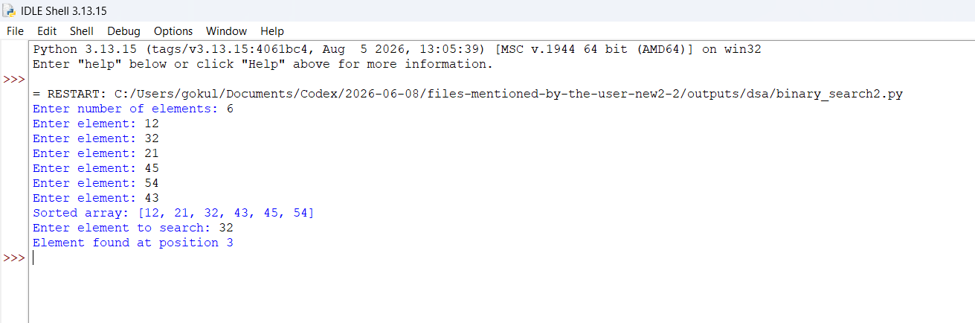

Explanation:
- Best Case: O(1) for the binary search after sorting
- Worst Case: O(n log n)
- Time Complexity: O(n log n)
- Space Complexity: O(n)
Reason: Sorting the array takes O(n log n) time in the average and worst case, while binary search takes O(log n) time. Since sorting takes more time than searching, the overall time complexity is O(n log n). The array requires O(n) space for storing the input elements.

Week-3:
a)write a program to implement Bubble Sort.

Program:

# Bubble Sort

# Taking number of elements
n = int(input("Enter number of elements: "))

# Taking array elements
arr = []

for i in range(n):
value = int(input("Enter element: "))
arr.append(value)

# Bubble Sort
for i in range(n - 1):
swapped = False

for j in range(n - 1 - i):
if arr[j] > arr[j + 1]:
# Swap elements
arr[j], arr[j + 1] = arr[j + 1], arr[j]
swapped = True

# Stop if array is already sorted
if not swapped:
break

print("Sorted array:", arr)

Output:

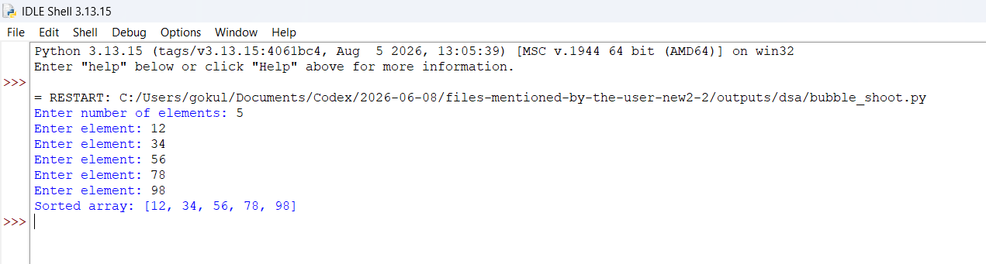

Explanation:
Complexity
- Best Case: O(n)
- Worst Case: O(n²)
- Time Complexity: O(n²)
- Space Complexity: O(1)
Reason: In the best case, when the array is already sorted, the algorithm makes one pass and stops because no swapping occurs, giving O(n) time. In the worst case, when the array is in reverse order, multiple comparisons and swaps are required, giving O(n²) time. Bubble Sort sorts the elements in the same array and uses only a few extra variables, so its space complexity is O(1).
s.no | Error obtained | Rectification
1. | Break statement written out side the loop | Rectified by writing it in side the loop
2. | Errors in defining the conditions | Rectified using proper

b)Write a program to implement Insertion Sort.
Program:
# Insertion Sort

# Taking number of elements
n = int(input("Enter number of elements: "))

# Taking array elements
arr = []

for i in range(n):
value = int(input("Enter element: "))
arr.append(value)

# Insertion Sort
for i in range(1, n):
key = arr[i]
j = i - 1

# Move elements greater than key one position ahead
while j >= 0 and arr[j] > key:
arr[j + 1] = arr[j]
j = j - 1

# Insert key at correct position
arr[j + 1] = key

print("Sorted array:", arr)

Output:
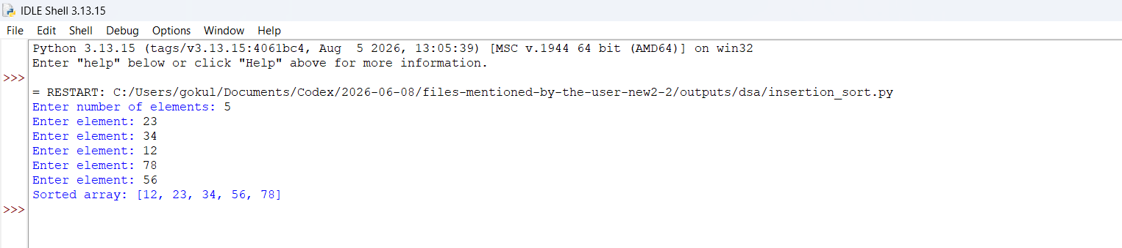

Explanation:
- Best Case: O(n)
- Worst Case: O(n²)
- Time Complexity: O(n²)
- Space Complexity: O(1)
Reason: The best case occurs when the array is already sorted. In this case, each element only needs one comparison, resulting in O(n) time. The worst case occurs when the array is in reverse order, because every element has to be compared with and shifted past all previous elements, resulting in O(n²) time. The algorithm sorts the array in place and uses only a few extra variables, so the space complexity is O(1).

- Write a program to implement Selection Sort.
Program:
# Selection Sort

# Taking number of elements
n = int(input("Enter number of elements: "))

# Taking array elements
arr = []

for i in range(n):
value = int(input("Enter element: "))
arr.append(value)

# Selection Sort
for i in range(n - 1):
min_index = i

for j in range(i + 1, n):
if arr[j] < arr[min_index]:
min_index = j

# Swap minimum element with current element
arr[i], arr[min_index] = arr[min_index], arr[i]

print("Sorted array:", arr)

Output:
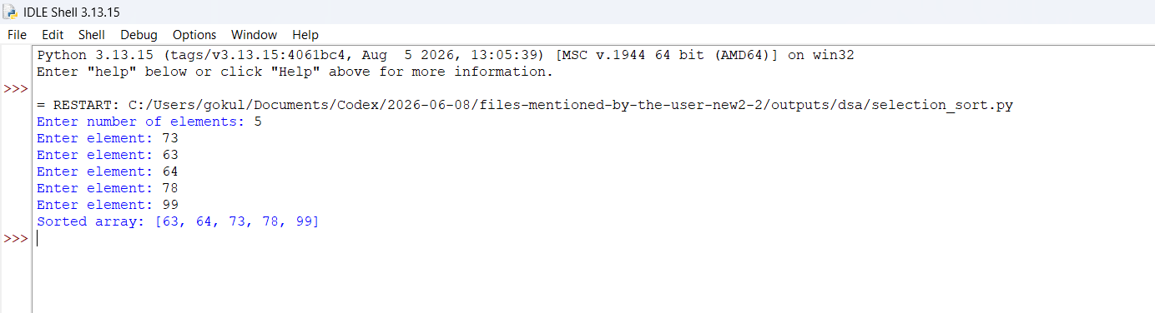
Explanation:
- Best Case: O(n²)
- Worst Case: O(n²)
- Time Complexity: O(n²)
- Space Complexity: O(1)
Reason: Selection Sort always searches through the remaining unsorted elements to find the minimum element, even if the array is already sorted. Therefore, the number of comparisons remains almost the same for both best and worst cases, resulting in O(n²) time complexity. The algorithm performs sorting within the original array and uses only a few extra variables, so its space complexity is O(1).

s.no | Error obtained | Rectification
1. | Break statement written out side the loop | Rectified by writing it in side the loop
2. | Errors in defining the conditions | Rectified using proper

Week-4;
A) write a python program to implement Quick sort, where the elements are taken from User
Aim: write a python program to implement Quick sort, where the elements are taken from user.
Program:
def quick_sort(arr):
# Base case: if the array has 0 or 1 element, it is already sorted
if len(arr) <= 1:
return arr

# Choose the middle element as the pivot
pivot = arr[len(arr) // 2]

# Create three lists for partitioning the elements
left = [x for x in arr if x < pivot] # Elements smaller than pivot
middle = [x for x in arr if x == pivot] # Elements equal to pivot
right = [x for x in arr if x > pivot] # Elements greater than pivot

# Recursively sort the left and right parts, then combine everything
return quick_sort(left) + middle + quick_sort(right)

# --- Main Program Execution ---
if __name__ == "__main__":
print("--- Quick Sort Program ---")

# 1. Ask the user for inputs separated by spaces
user_input = input("Enter numbers separated by spaces (e.g., 5 2 9 1 7): ")

# 2. Convert the input string into a list of integers
# .split() breaks the text by spaces, and int(x) converts each piece to a number
try:
numbers = [int(x) for x in user_input.split()]

# Check if the user actually entered any numbers
if not numbers:
print("You didn't enter any numbers!")
else:
# 3. Sort the numbers and print the final result
sorted_numbers = quick_sort(numbers)
print("\nOriginal array:", numbers)
print("Sorted array: ", sorted_numbers)

except ValueError:
print("\n[Error]: Please enter only valid integers separated by spaces.")

output:
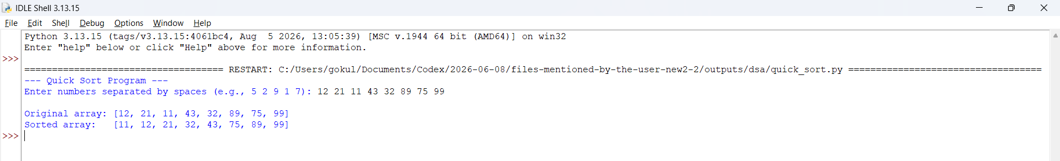

Explanation:
This Python program uses the Quick Sort algorithm to sort elements in ascending order. It takes n elements from the user and stores them in a list. The first element is chosen as the pivot, and the remaining elements are divided into left (smaller or equal) and right (greater). The function recursively sorts both parts and combines them as left + pivot + right to produce the sorted array.

Error Table:
s.no | Error obtained | Rectification
1. | Mistakes in main logic | Rectified
2. | Errors in conditions | Rectified
4B) write a python program to implement merge sort, where the elements are taken from user.
AIM: write a python program to implement merge sort, where the elements are taken from user.
Program:
def main():
print("rollno : cse25126\name : M.Gokul krishna\n")
n = int(input("Enter size of array: "))
arr = []
for i in range(n):
arr.append(int(input(f"enter {i+1} element: ")))
quick_sort(arr, 0, n-1)
print(arr)

def quick_sort(a, low, high):
if low < high:
pivot = a[low] # store pivot VALUE, not index
i = low - 1
j = high + 1

while True:
i += 1
while a[i] < pivot:
i += 1
j -= 1
while a[j] > pivot:
j -= 1
if i >= j:
break
a[i], a[j] = a[j], a[i]

quick_sort(a, low, j) # left part (includes j)
quick_sort(a, j + 1, high) # right part

if __name__ == '__main__':
main()

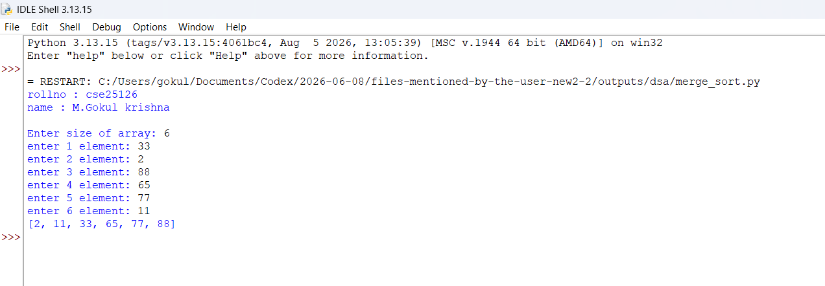
output:
Explanation:
This Python program uses the Merge Sort algorithm to sort elements in ascending order. It first takes n elements from the user and stores them in a list. The merge_sort() function divides the list into two halves recursively until each sublist has one element. Then, it merges the sublists by comparing elements and placing the smaller one first. The process continues until the entire list is sorted.
Error Table:
s.no | Error obtained | Rectification
1. | Mistakes in induntation | Rectified using proper spaces
2. | Errors in conditions | Rectified

Week 5
5a) Write a program to implement SLL with the below operations. Create linked list, Insert Beginning, Insert End, Insert at Index, delete by value, delete first node, delete last node, count number of nodes, display/transverse exit.
AIM: Write a program to implement SLL with the below operations. Create linked list, Insert Beginning, Insert End, Insert at Index, delete by value, delete first node, delete last node, count number of nodes, display/transverse exit.
Program:
def main():
print("CSE25126 M.Gokul krishna\n")
my_LinkedList = None
while True:
print(
"1.create\n2.insert at beginning\n3.insert at end\n4.insert at certain position\n5.delete first node\n6.delete last node\n7.delete specific node\n"
"8.count\n9.display\n10.exit"
)
option = input("Enter your choice: ")
if option == "1":
my_LinkedList = LinkedList()
print("linked list successfully created")
elif my_LinkedList is None:
print("please create the linked list first (option 1)")
elif option == "2":
my_LinkedList.insert_begin(int(input("Enter the data: ")))
print("element is inserted")
elif option == "3":
my_LinkedList.insert_end(int(input("Enter the data: ")))
print("element inserted")
elif option == "4":
my_LinkedList.insert_position(
int(input("Enter the data: ")), int(input("Enter the position: "))
)
elif option == "5":
my_LinkedList.delete_begin()
elif option == "6":
my_LinkedList.delete_end()
elif option == "7":
my_LinkedList.delete_position(int(input("Enter position: ")))
elif option == "8":
count = my_LinkedList.size()
print("the size of linked list is {}".format(count))
elif option == "9":
my_LinkedList.display()
elif option == "10":
print("exiting the program")
break
else:
print("option not defined")

class LinkedList:
def __init__(self):
self.head = None

def insert_begin(self, data):
node = Node(data)
if self.head is None:
self.head = node
return
node.next = self.head
self.head = node

def insert_end(self, data):
if self.head is None:
self.insert_begin(data)
return
node = Node(data)
temp = self.head
while temp.next:
temp = temp.next
temp.next = node

def size(self):
temp = self.head
count = 0
while temp:
temp = temp.next
count += 1
return count

def insert_position(self, data, pos):
# positions are 1-indexed: pos=1 means new head
n = self.size()
if pos < 1 or pos > n + 1:
print("position not available")
return
if pos == 1:
self.insert_begin(data)
print("element inserted")
return
node = Node(data)
temp = self.head
count = 1
while count < pos - 1:
temp = temp.next
count += 1
node.next = temp.next
temp.next = node
print("element inserted")

def display(self):
if self.head is None:
print("The linked list is empty")
return
temp = self.head
while temp:
print(temp.data, end=" <-> ")
temp = temp.next
print("None")

def delete_begin(self):
if self.head is None:
print("The Linked list is empty")
return
self.head = self.head.next
print("first node deleted")

def delete_end(self):
if self.head is None:
print("The Linked list is empty")
return
if self.head.next is None:
self.head = None
print("last node deleted")
return
temp = self.head
while temp.next.next:
temp = temp.next
temp.next = None
print("last node deleted")

def delete_position(self, pos):
# positions are 1-indexed: pos=1 means head
if self.head is None:
print("Empty linked list")
return
n = self.size()
if pos < 1 or pos > n:
print("position does not exist")
return
if pos == 1:
self.head = self.head.next
print("node at position is deleted")
return
temp = self.head
count = 1
while count < pos - 1:
temp = temp.next
count += 1
temp.next = temp.next.next
print("node at position is deleted")

class Node:
def __init__(self, data):
self.data = data
self.next = None

if __name__ == "__main__":
main()

output: 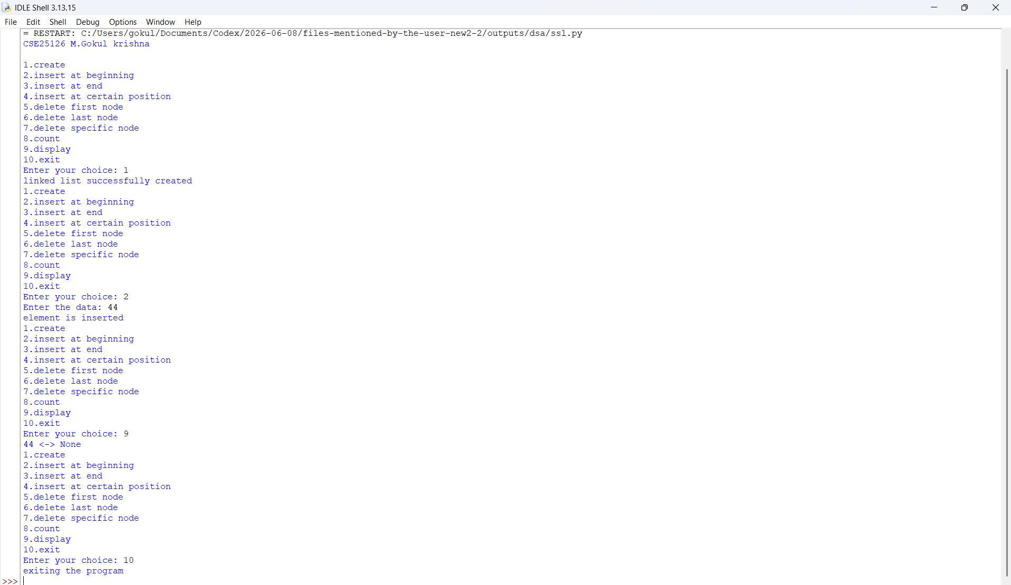

Explanation:
This Python program implements a Singly Linked List (SLL) using a menu-driven approach. Each node contains data and a next pointer, while the head points to the first node. The program supports creating the list, inserting nodes (beginning, end, index), deleting nodes, counting nodes, and displaying the list. The display output is in the format:
Error Table:
s.no | Error obtained | Rectification
2. | Errors in conditions | Rectified by taking proper
3. | Errors in node linking | Rectified
4. | Errors in insertion and deletion | Rectified
5. | Errors in index handling | Rectified

Week 6
Q)Write a python program to implement stack operations such as push, pop, peek, display using an array and a linked list
AIM: a python program to implement stack operations such as push, pop, peek, display using an array and a linked list
Stack using arrays:
Program:
class StackArray:
def __init__(self):
self.stack = []

def push(self, data):
self.stack.append(data)
print(data, "pushed")

def pop(self):
if len(self.stack) == 0:
print("Stack is empty")
else:
print("Popped:", self.stack.pop())

def peek(self):
if len(self.stack) == 0:
print("Stack is empty")
else:
print("Top element:", self.stack[-1])

def display(self):
if len(self.stack) == 0:
print("Stack is empty")
else:
print("Stack:", end=" ")
for i in range(len(self.stack) - 1, -1, -1):
print(self.stack[i], end=" ")
print()

s = StackArray()

while True:
print("\n--- STACK USING ARRAY ---")
print("1. Push")
print("2. Pop")
print("3. Peek")
print("4. Display")
print("5. Exit")

choice = int(input("Enter choice: "))

if choice == 1:
value = int(input("Enter value: "))
s.push(value)

elif choice == 2:
s.pop()

elif choice == 3:
s.peek()

elif choice == 4:
s.display()

elif choice == 5:
print("Program Ended")
break

else:
print("Invalid Choice")

Output:
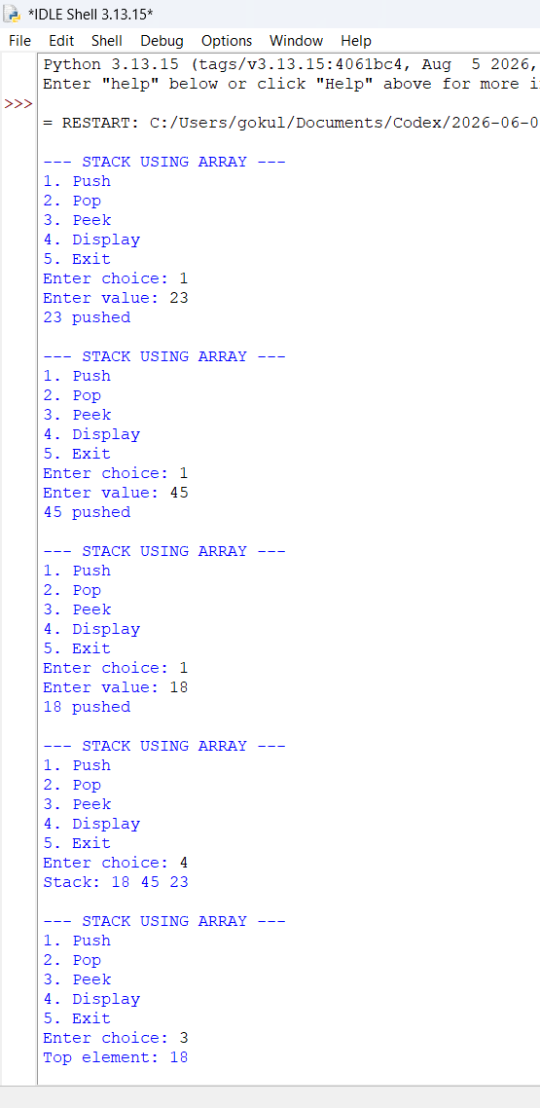

Stacks using linked lists:
class Node:
def __init__(self, data):
self.data = data
self.next = None

class StackLinkedList:
def __init__(self):
self.top = None

def push(self, data):
new_node = Node(data)
new_node.next = self.top
self.top = new_node
print(data, "pushed")

def pop(self):
if self.top is None:
print("Stack is empty")
else:
print("Popped:", self.top.data)
self.top = self.top.next

def peek(self):
if self.top is None:
print("Stack is empty")
else:
print("Top element:", self.top.data)

def display(self):
if self.top is None:
print("Stack is empty")
else:
temp = self.top
print("Stack:", end=" ")
while temp:
print(temp.data, end=" ")
temp = temp.next
print()

s = StackLinkedList()

while True:
print("\n--- STACK USING LINKED LIST ---")
print("1. Push")
print("2. Pop")
print("3. Peek")
print("4. Display")
print("5. Exit")

choice = int(input("Enter choice: "))

if choice == 1:
value = int(input("Enter value: "))
s.push(value)

elif choice == 2:
s.pop()

elif choice == 3:
s.peek()

elif choice == 4:
s.display()

elif choice == 5:
print("Program Ended")
break

else:
print("Invalid Choice")

Out Put:
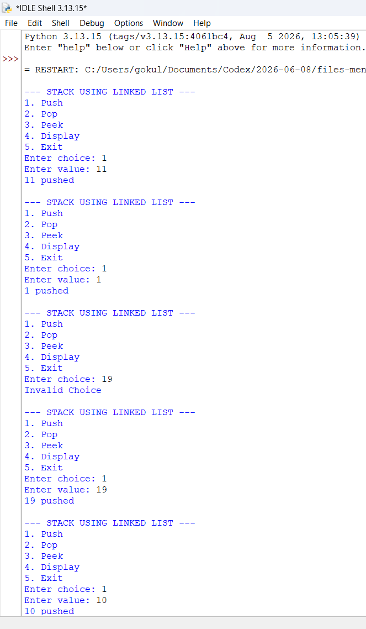
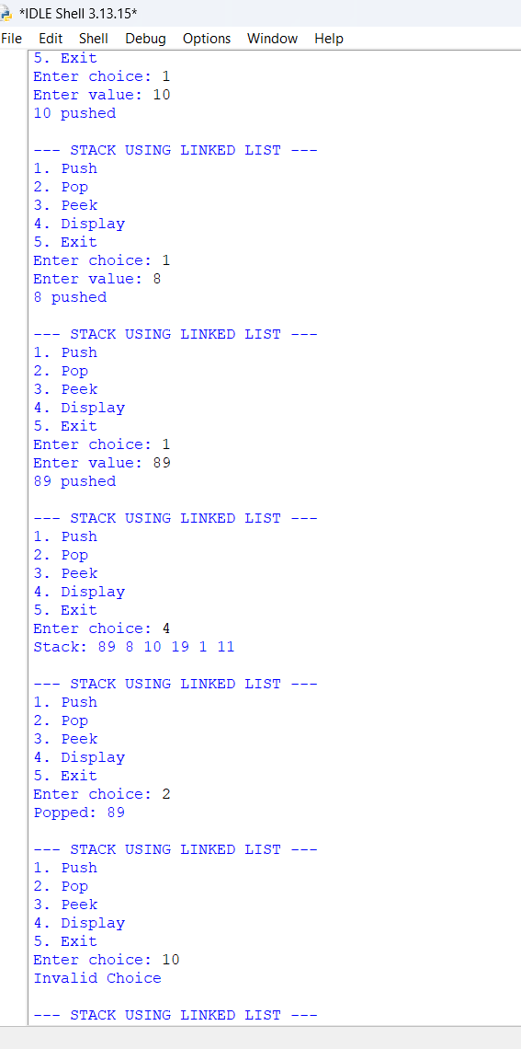

Explanation:
program implements a Stack using a list. It first creates an empty list called stack and sets the maximum size using the MAX variable. A while loop displays the menu repeatedly until the user chooses Exit.
Inside the loop, the user's choice is taken using input(). The program uses if-elif statements to perform different operations. In Push, it checks whether the stack is full; if not, it inserts the element using stack.append(). In Pop, it checks whether the stack is empty and removes the top element using stack.pop(). The Peek operation displays the top element using stack[-1] without removing it, and Display prints all elements from the top to the bottom of the stack.
The program also handles overflow and underflow conditions prevent invalid operations.

S.No | Error Obtained | Rectification
1 | Errors in conditions | Fixed the conditional statements.
2 | Errors in Push and Pop | Used correct push and pop operations.
3 | Errors in top pointer | Corrected top element handling.
4 | Errors in Display | Fixed the display logic.

